# CS 255 System Design Document

## UML Diagrams

### UML Use Case Diagram

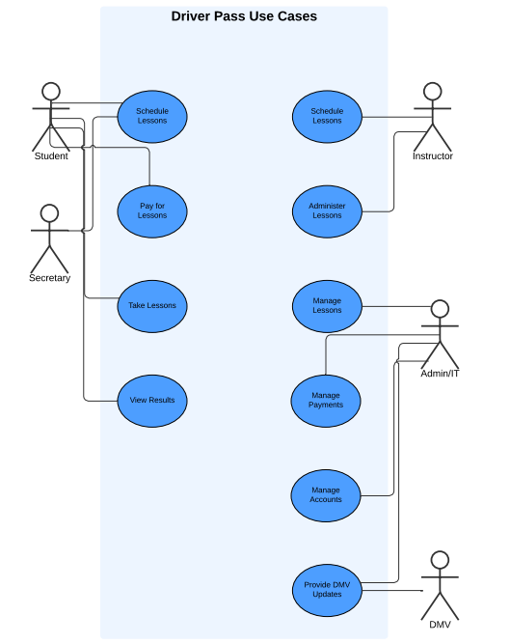

### UML Activity Diagrams

### UML Sequence Diagram

### UML Class Diagram

## Technical Requirements

**1. Hardware Requirements:**

* **Cloud-Based Hosting**: The system will be hosted on a cloud-based Unix environment, which ensures reliability, scalability, and cost efficiency.
* **User Devices**: The system must support desktop computers, laptops, and mobile devices running iOS or Android for users to access the platform.

**2. Software Requirements:**

* **Operating Systems**: The system must be compatible with modern operating systems, including Windows, macOS, iOS, and Android.
* **Web Browsers**: Support for modern web browsers like Google Chrome, Firefox, Safari, and Edge is necessary to ensure compatibility across devices.

**3. Tools:**

* **Development Frameworks**: Use of the web development frameworks React for the frontend and Node.js for the backend. These frameworks will allow for a unified code base to be created for web and mobile applications.
* **Database Management**: PostgreSQL to manage user accounts, lesson scheduling, payment processing, and other critical system data. PostgreSQL is the recommended database management tool of AWS.

**4. Infrastructure Requirements:**

* **Cloud Hosting Provider**: AWS environments for hosting the application.
* **Database Server**: An AWS hosted PostgreSQL database server for storing user information, lesson schedules, and other system data.
* **Security Infrastructure**: Encryption protocols to secure user data during transmission (e.g., SSL/TLS), along with secure login and password recovery processes.